Assignment 1

Poorna Pallavi Tekkali

1002160637

**KNN algorithm using 10-Fold cross validation.**

**Libraries Data:**   
Python programming efficient practice describes importing libraries such as csv , random and math .This explanation closely resembles standard instructions and documentation that may be found in official library documentation as well as instructional resources.

**KNN Class:**

We write a function called **k_fold_cross_validation_data,** which conducts K-Fold Cross-Validation on input data X (features) and Y (labels), and returns a list of accuracies for each fold.   
This function creates a KFold object, loops over each fold, and sets splits the data .   
To prepare the KNN classifier for each fold, we divide the data into training and testing sets, train it, predict the labels for the test set, measure accuracy, and store the results in a arry.

**Load the Datasets:**  
  
We defined a list dataset containing the filenames of the datasets (cancer.csv, hayes.csv, car.csv).

**Loop Over Datasets:**

We loop over each dataset filename in the datasets list.

**For All dataset:**

By using the **k_fold_cross_validation_data** function, we assess the custom KNN algorithm using 10-Fold Cross-Validation.   
Using the cross-validation list of accuracies, we compute the average accuracy.   
We report each dataset's mean accuracy.

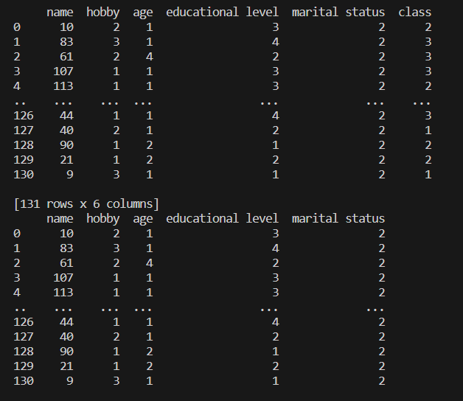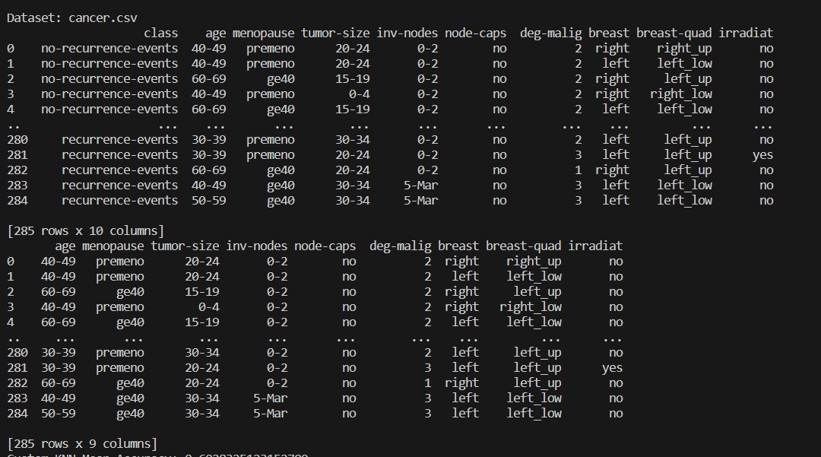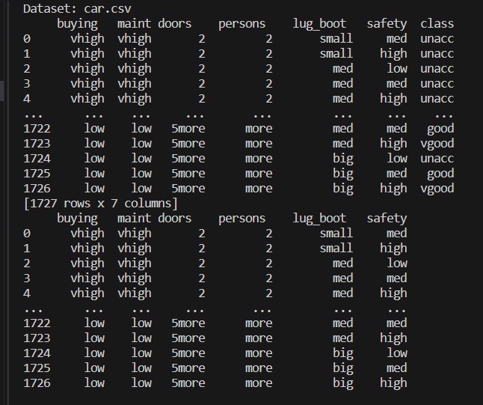

**Result:**

|  |  |  |
| --- | --- | --- |
| **hayes+roth** | **car+evaluation** | **breast+cancer** |
| **47%** | **85%** | **73%** |

OUTPUT:

